Tool – Data Analysis – Moving Average

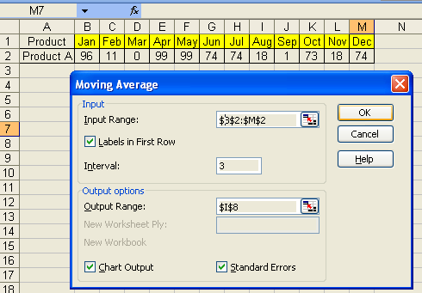

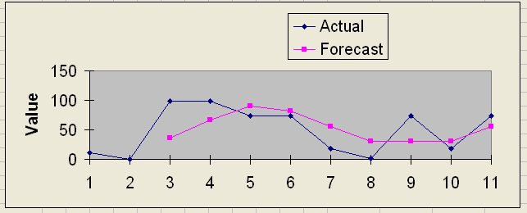

Add data labels to a chart
- Double-click the first data point in the Forecast series to open the Format Data Series dialog box.
- On the Data Labels tab, select the Value check box, and then click OK.
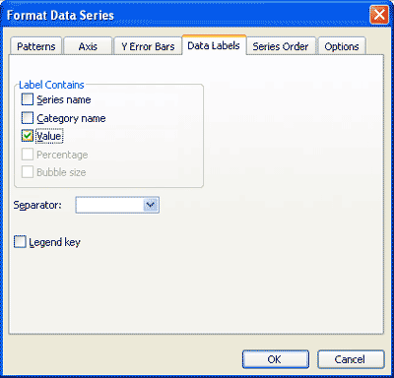
- Double-click the first data label to open the Format Data Label dialog box.
- On the Font tab, set the font size to 8.
- On the Number tab, select number from the list on the left.
- Set the decimal places to 0.
- Click OK.
Your chart now clearly shows your forecasted inventory levels and identifies each month’s optimal ending quantity.
